Performance Matters - Unify
Managing District / School Admin Accounts through PowerSchool

  - Search for the staff member in PowerSchool.
  - Select Security Settings.
  - Select Applications.
  - On the bottom of page, check the box if the user will be a school administrator.

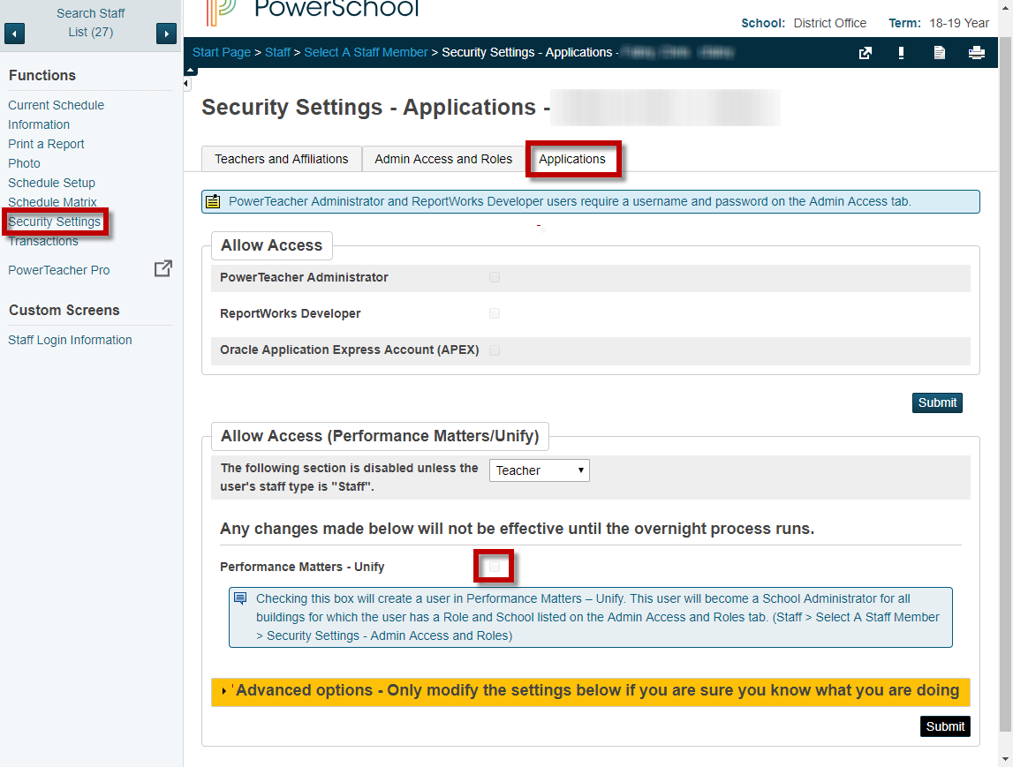

  - On the bottom of the page, if you click on the Advanced options and check the PM District User box, it will create a District User in Performance Matters - Unify.
  - If you put in an Alternate User Name (Email), users will be able to go directly to unify.performancematters.com and login with their credentials.
